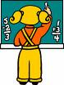
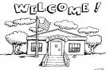
Let’s talk about SCHOOL
Conversation cards 
What school do you go to?
Where is it?
How do you get there?
What time do you get up on a school day?
Who wakes you up?
What’s your favourite subject?
Why do you like it?

What time does school start? When does it finish?
Are there any breaks?
What time do you go to bed
on the eve of a school day?
Do you ever stay up late?
Is your school far from your home? How long does it take you to get to school?
Where is your school located?
Is it easy to get there?
What classes don’t you like?
Why not?
How many students are there in your school?
How many in your class?
Have you ever been late for class? If so, why?
Was the teacher angry?

Where do you have lunch?
What do you usually eat for lunch?
What do you do during breaks?
Talk about it.
Have you ever fallen asleep in class?
If so, why? Explain.
What subjects are you good at? What subjects are difficult for you?
Have you ever been punished at school? Why?
What was the punishment?
Do you ever skip class?
If so, what do you do?
What do you like best about your school?
Explain.

Give examples of school rules. Have you ever broken any?
(e.g. you must wear a uniform; you mustn’t eat in the classroom)

2

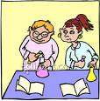
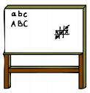
Interview a friend (or do it for yourself)
Do you like English? Yes,  I love it.  Do you like exams? No,  I hate them. | love | like   | don’t mind | don’t  like   | hate  
English
exams
Geography
History
holidays
homework
Maths
PE (sports)
Science

1
3


Match
desk
laboratory
school bus
teacher
whiteboard

4

5

